



**Sample Migration - Any Infrastructure to AWS**Solution Implementation overview

In this section, we will demo a full [Migration](javascript:void(0);) [Project](javascript:void(0);) - from [Project](javascript:void(0);) creation to [launching](javascript:void(0);) machines in [Cutover](javascript:void(0);) Mode. The [Project](javascript:void(0);) will use our local set of server machines - an application server, a web server, and a database server as the [Source](javascript:void(0);) infrastructure. These machines will be migrated to AWS East (North Virginia) - the [Target](javascript:void(0);) infrastructure.

**Note**: In addition to reviewing this documentation, you can complete the free [CloudEndure Migration Training](https://www.aws.training/Details/eLearning?id=39068" \t "_blank) course on AWS.

**Creating the Project**

The first step is creating the [Migration](javascript:void(0);) [Project](javascript:void(0);).

Click the gray plus sign on the top-left of the CloudEndure [User Console](javascript:void(0);) to create a new [Project](javascript:void(0);).

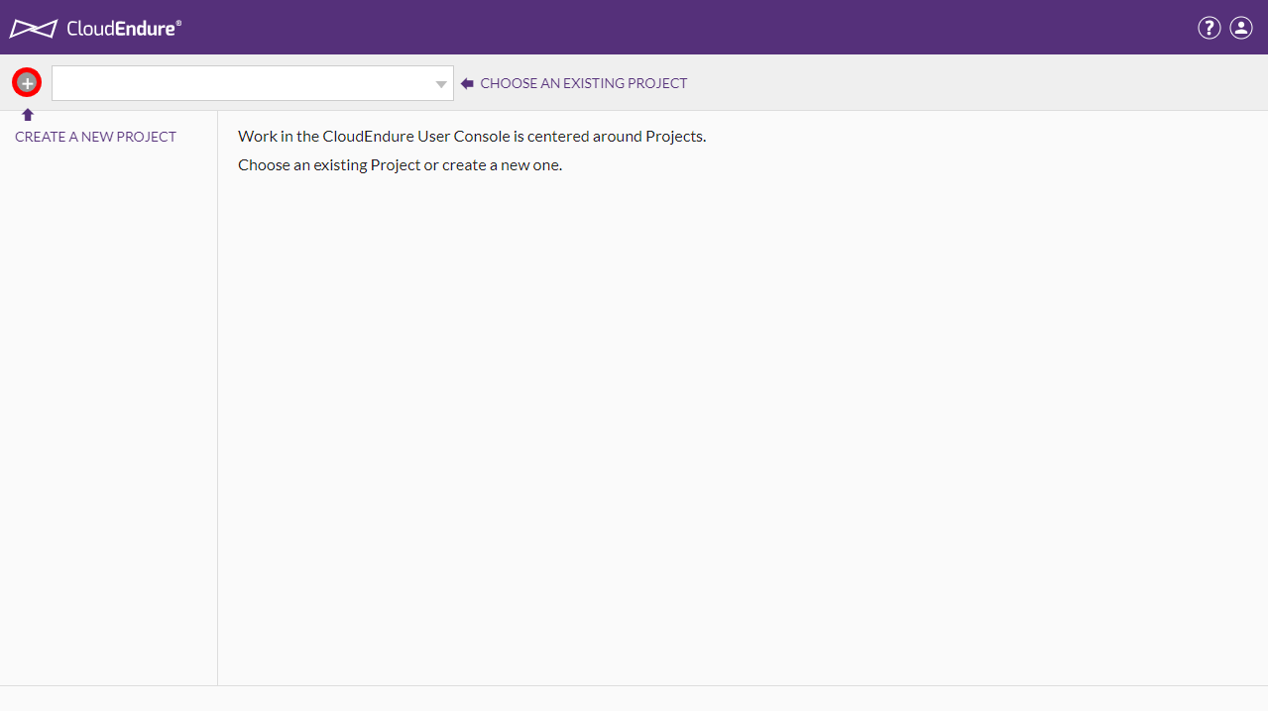

Next, populate the fields in the **Create New Project** dialog.

* [Project](javascript:void(0);) name - [Migration](javascript:void(0);) to AWS
* [Project](javascript:void(0);) type - [Migration](javascript:void(0);)
* [Target](javascript:void(0);) infrastructure - Amazon Web Services
* [License](javascript:void(0);) - Valid [Migration](javascript:void(0);) [License](javascript:void(0);)

Click **CREATE PROJECT.**

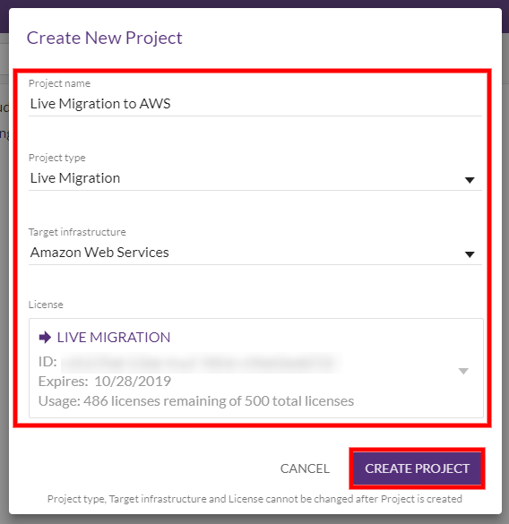

The new [Project](javascript:void(0);) will be created. The next step is setting up the [Project](javascript:void(0);).

**Generating and Using AWS Credentials**

Upon [Project](javascript:void(0);) creation, the [User Console](javascript:void(0);) will notify you that [Credentials](javascript:void(0);) and [Replication Settings](javascript:void(0);) need to be configured. Click **CONTINUE**.

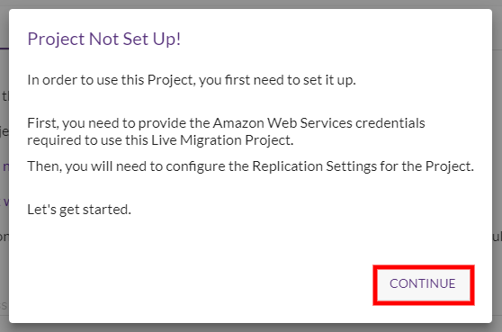

You will be automatically redirected to the **Setup & Info > AWS** [Credentials](javascript:void(0);) tab. Here, you will have to enter your **AWS Access Key ID** and **AWS Secret Access Key**.

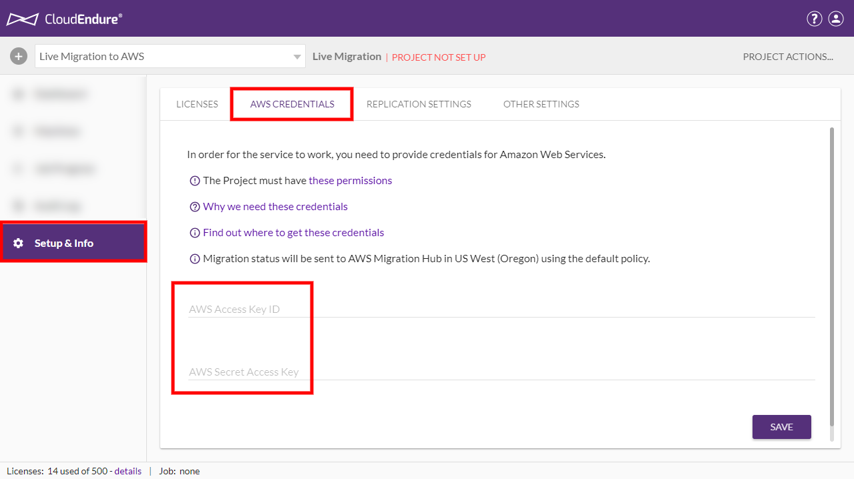

A detailed explanation of how to generate the required AWS [Credentials](javascript:void(0);) can be found [here](https://docs.cloudendure.com/Content/Generating_and_Using_Your_Credentials/Working_with_AWS_Credentials/Generating_the_Required_AWS_Credentials/Generating_the_Required_AWS_Credentials.htm).

Once you have generated your AWS [Credentials](javascript:void(0);), you will need to input them into the appropriate fields in the **AWS CREDENTIALS** tab. Copy your Access Key ID and Secret Access Key from AWS and paste them into the corresponding fields in the CloudEndure [User Console](javascript:void(0);). Click **SAVE**.

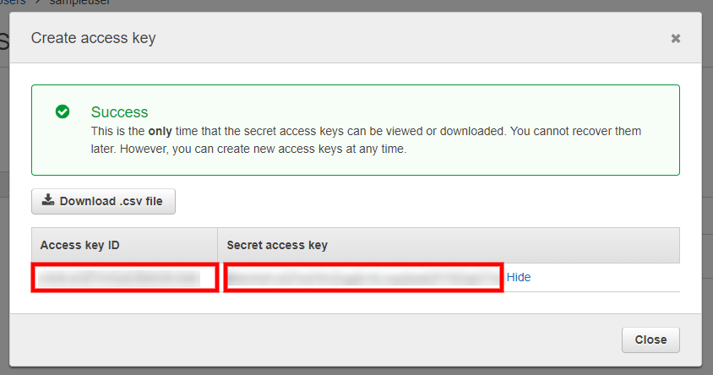

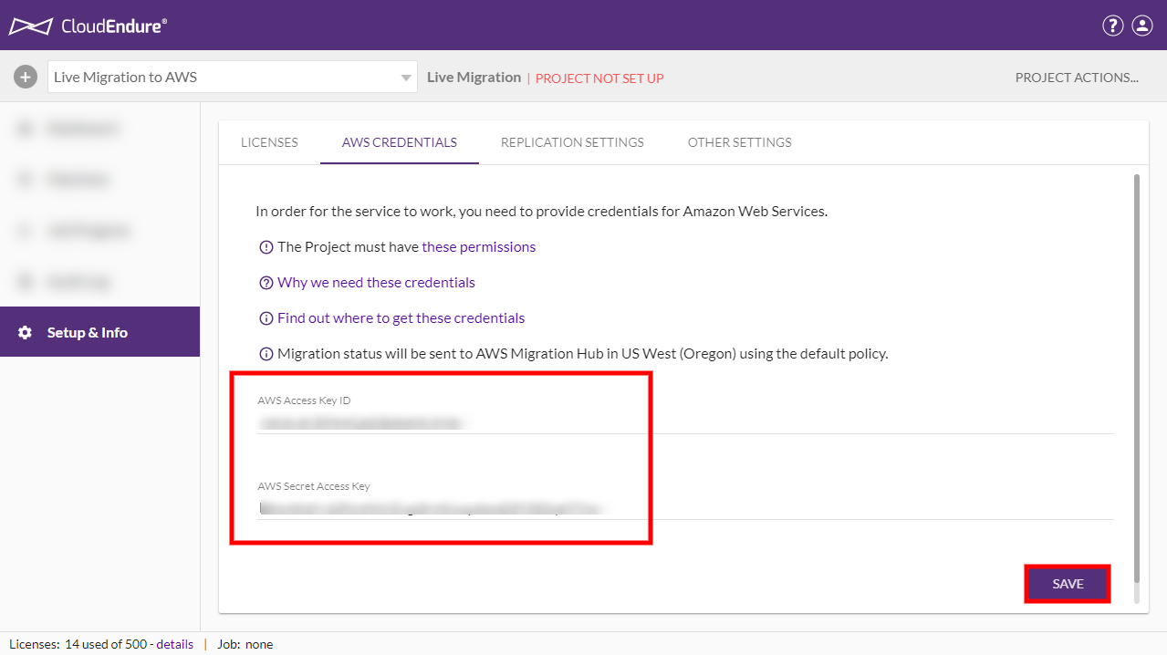

The next step is configuring your [Replication Settings](javascript:void(0);).

**Configuring your Replication Settings.**

Once you save your AWS [Credentials](javascript:void(0);), you will be automatically redirected to the **Setup & Info > REPLICATION SETTINGS** tab. Here you will need to select your [Migration](javascript:void(0);) [Source](javascript:void(0);) and [Target](javascript:void(0);) infrastructures and configure various [Replication Settings](javascript:void(0);).

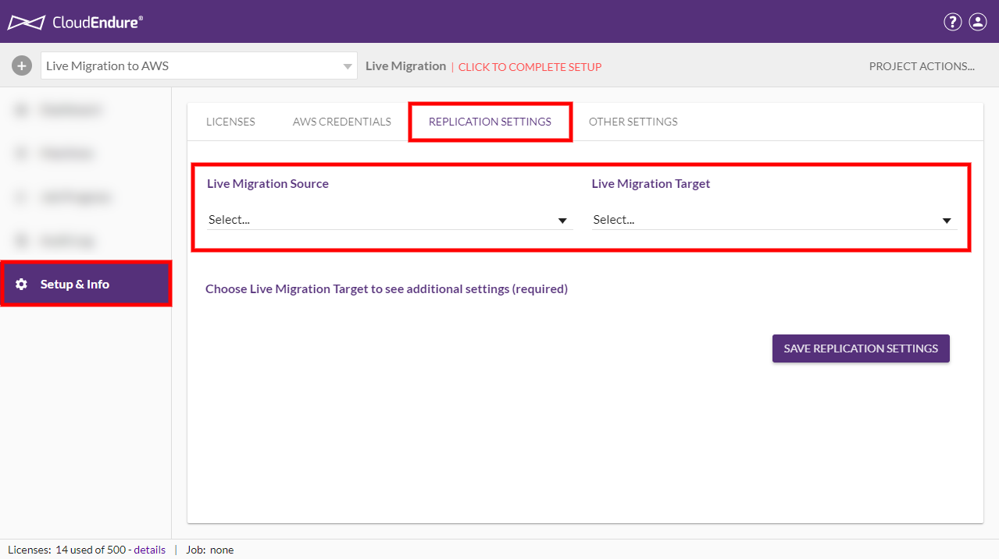

We selected **Other Infrastructure** as our [Source](javascript:void(0);), since we are migrating our local machines. We selected **AWS US East (North Virginia)** as our [Target](javascript:void(0);) infrastructure - the location to which we will be migrating our machines.

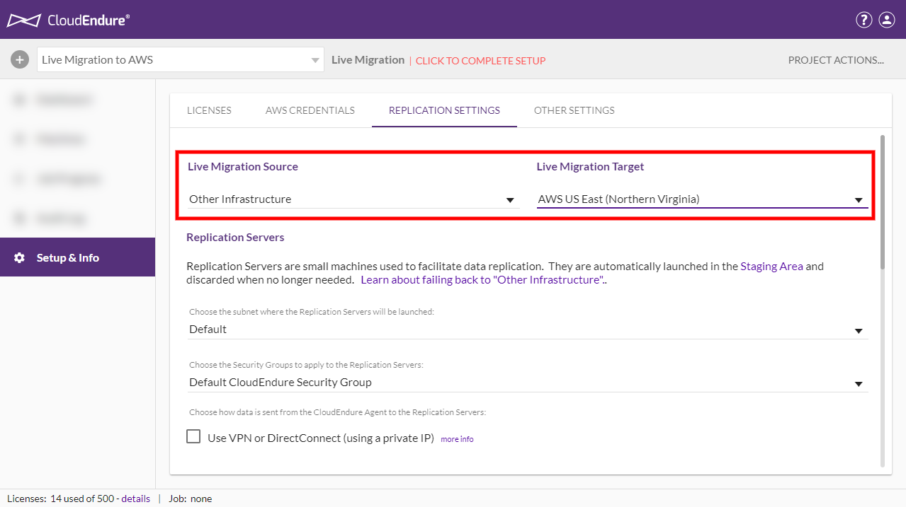

Once the [Source](javascript:void(0);) and [Target](javascript:void(0);) infrastructures have been selected, a variety of other configurable settings will appear. You can learn more about these various settings [here](https://docs.cloudendure.com/Content/Defining_Your_Replication_Settings/Defining_Replication_Settings_for_AWS/Defining_Replication_Settings_for_AWS.htm).

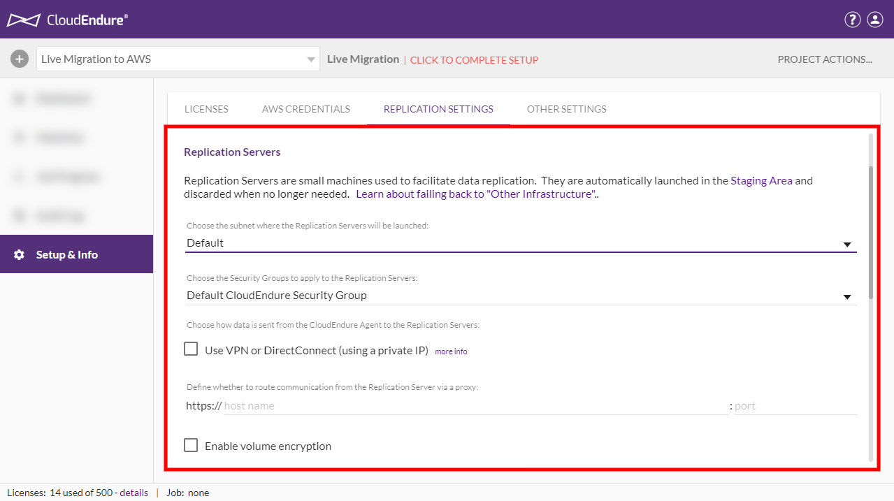

For our purposes, we will be performing a simple migration with default AWS settings. As a result, we will not be making any additional changes to the [Replication Settings](javascript:void(0);). Once you have configured all of your [Replication Settings](javascript:void(0);), scroll to the bottom and click **SAVE REPLICATION SETTINGS.**

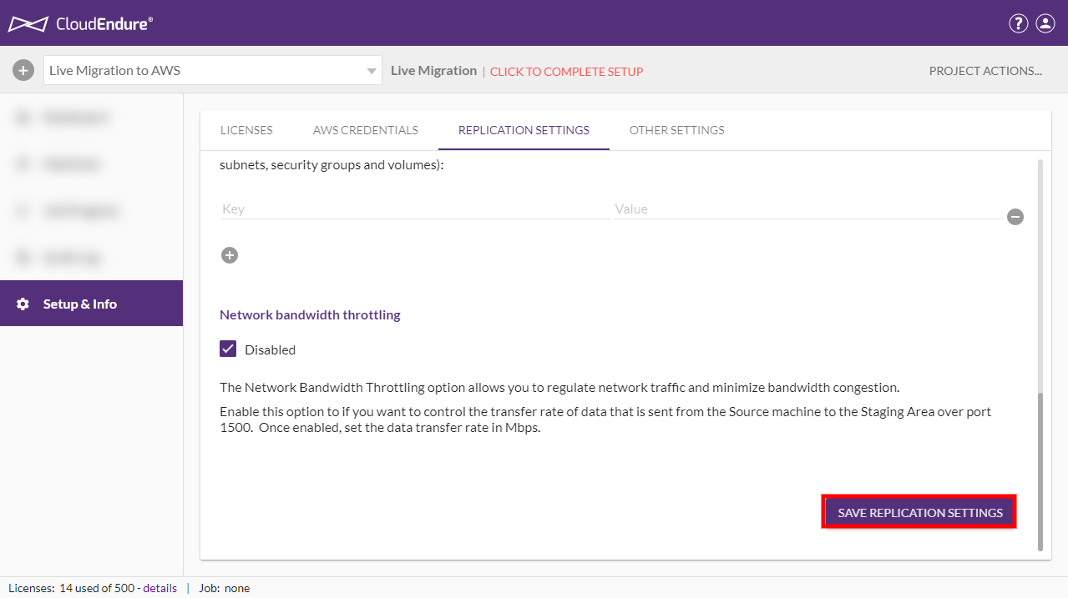

The next step is adding machines to your [Project](javascript:void(0);) by installing the CloudEndure User [Agent](javascript:void(0);) on your [Source](javascript:void(0);) machines.

**Installing the CloudEndure User Agent on your Source Machines**

Once you save your [Replication Settings](javascript:void(0);), you will be prompted to install the CloudEndure User [Agent](javascript:void(0);) on your [Source](javascript:void(0);) machines. Click on **SHOW ME HOW**to be redirected to the **Machines** tab.

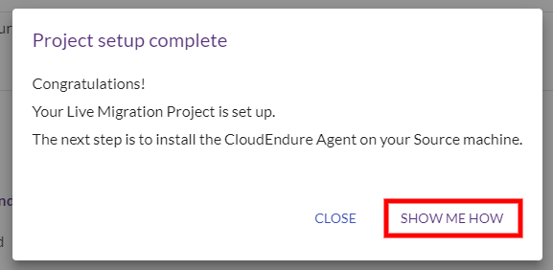

Since no machines are currently installed in the [Project](javascript:void(0);), the Machines tab will show the **How To Add Machines** instructions.

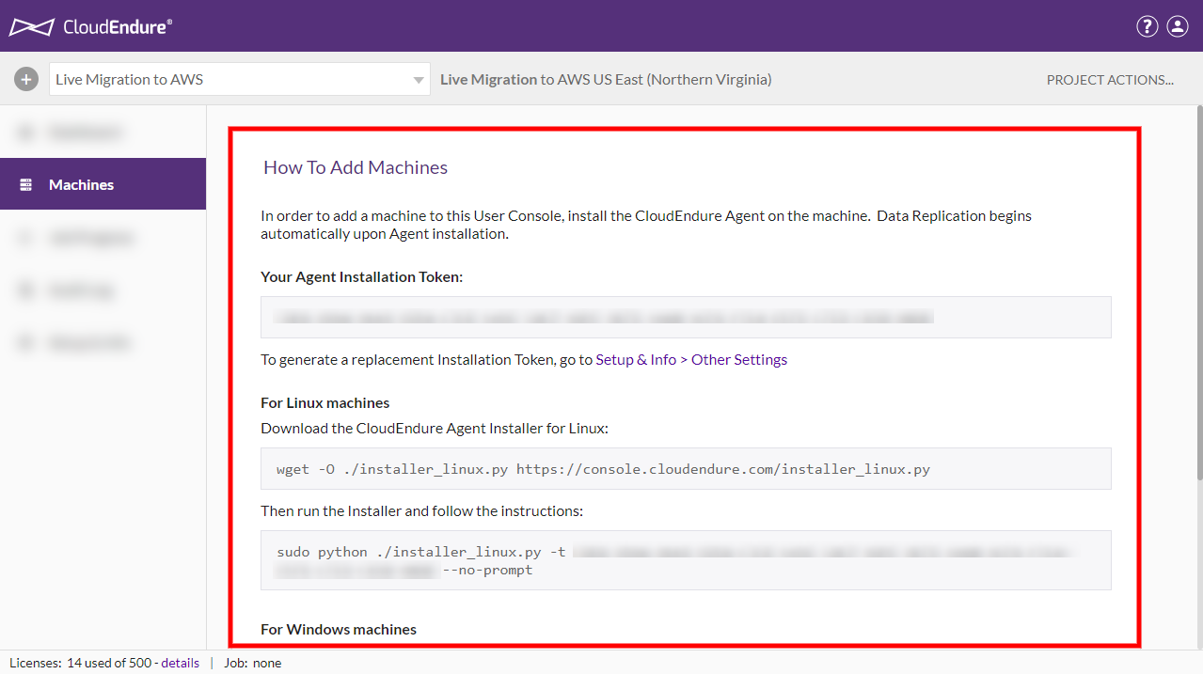

Use these instructions to install the CloudEndure User [Agent](javascript:void(0);) on your [Source](javascript:void(0);) machines. In our case, our [Source](javascript:void(0);) machines - an application server, a web server, and a database server are all running Debian GNU / Linux 9. We will therefore use the instructions under the **For Linux machines** header.

**Note**: We ensured that CloudEndure and AWS support our machines by looking at the [Supported Operating Systems documentation](https://docs.cloudendure.com/Content/Getting_Started_with_CloudEndure/Supported_Operating_Systems/Supported_Operating_Systems.htm) prior to installing the machines.

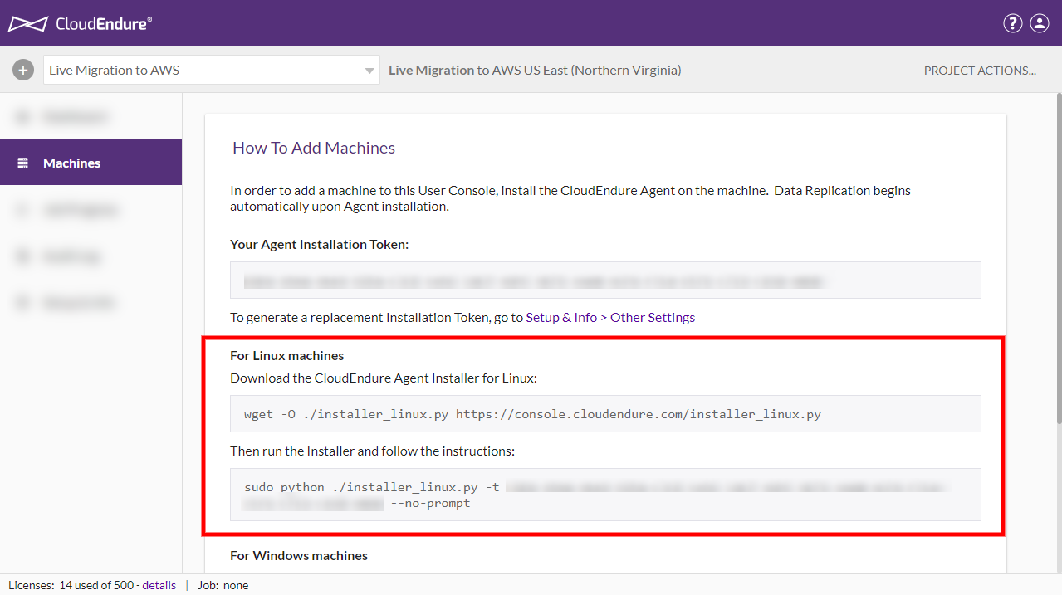

Install the User [Agent](javascript:void(0);) by running the [Agent](javascript:void(0);) download prompt on each [machine](javascript:void(0);)

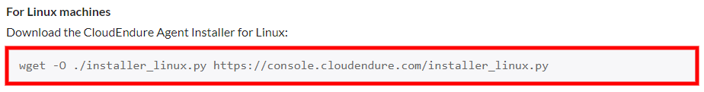

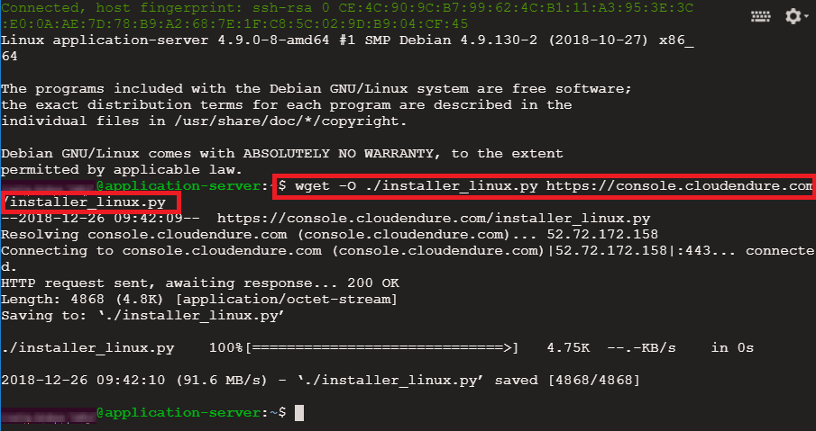

Then run the [Agent](javascript:void(0);) installation prompt.

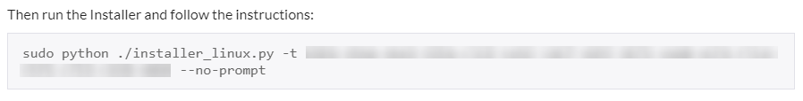

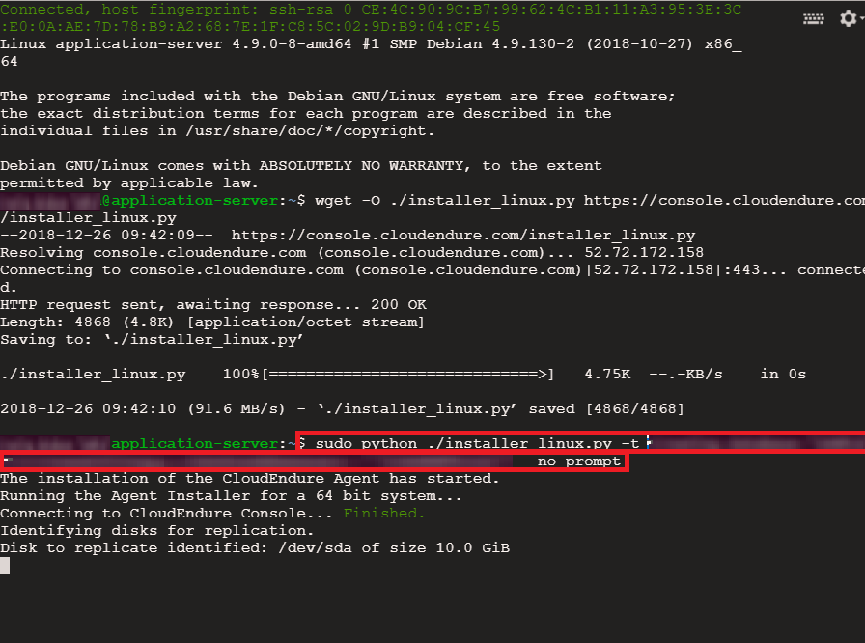

The CloudEndure [Agent](javascript:void(0);) will be downloaded and installed. You will be notified when the [Source machine](javascript:void(0);) has been added to the CloudEndure Console.

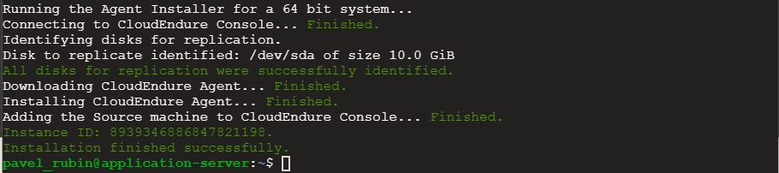

Repeat these step for all machines. You can always access the **How To Add Machines** dialog from the **Help Menu** on the top-right hand side of the Console.

  
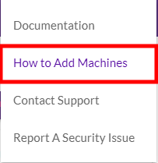

Once the [Source](javascript:void(0);) machines are added to the [User Console](javascript:void(0);), they will undergo several initial replication steps.

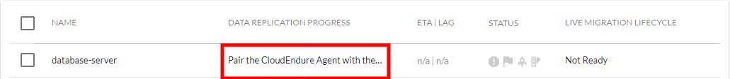

A detailed breakdown of the initiation steps can be found in the **Machine Details View** by clicking on an individual [machine](javascript:void(0);) name.

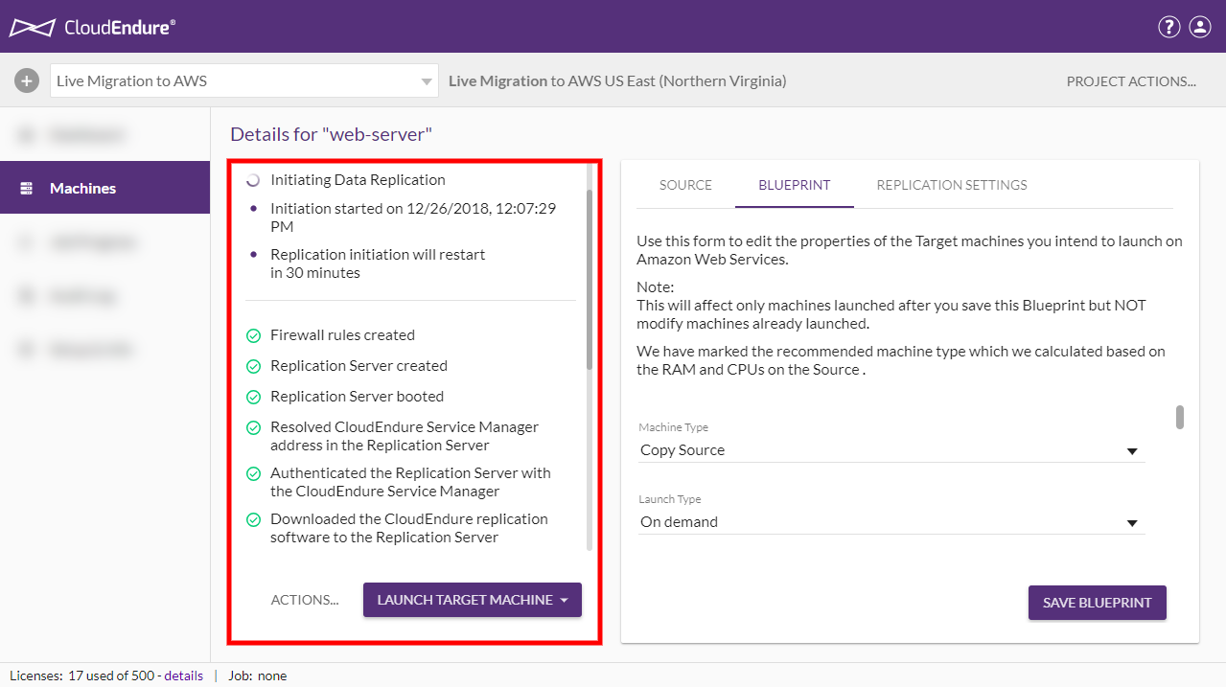

[Data Replication](javascript:void(0);) will then begin. The progress bar under the **DATA REPLICATION PROGRESS** column indicates the percent of data that has been replicated. The estimated time left is shown under the **ETA | LAG** column.

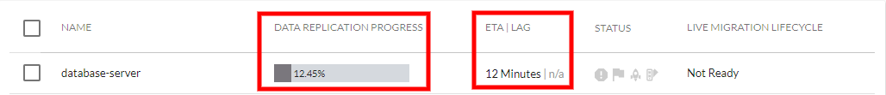

Once the machines have been successfully added, they will show **Continuous Data Replication** under the **DATA REPLICATION PROGRESS** column and **Ready for Testing** under the **MIGRATION LIFECYCLE** column. This means that the machines are functioning correctly with no [lag](javascript:void(0);) and are ready to be migrated. Here we can see all three of our machines.

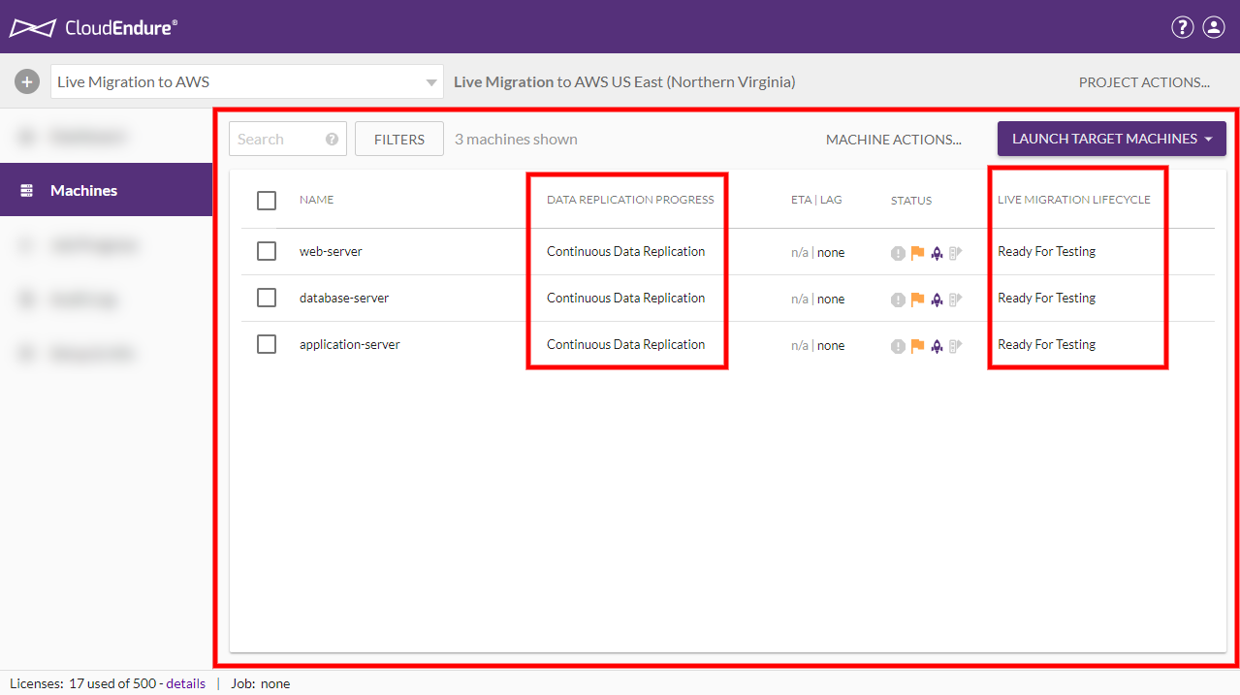

The next step is configuring the [Target machine](javascript:void(0);) Blueprint.

**Configuring the Target Machine Blueprint**

Once your [Source](javascript:void(0);) machines have been added to the CloudEndure [User Console](javascript:void(0);), you can configure the [Target machine](javascript:void(0);) Blueprint. The Blueprint is a set of instructions on how to launch a [Target machine](javascript:void(0);) for the selected [Source machine](javascript:void(0);). The Blueprint settings will serve as the base settings for the creation of the [Target machine](javascript:void(0);).

You can access a [machine](javascript:void(0);)'s Blueprint through the Machine Details View by clicking on a [machine](javascript:void(0);) name on the Machine List View on the **Machines** tab.

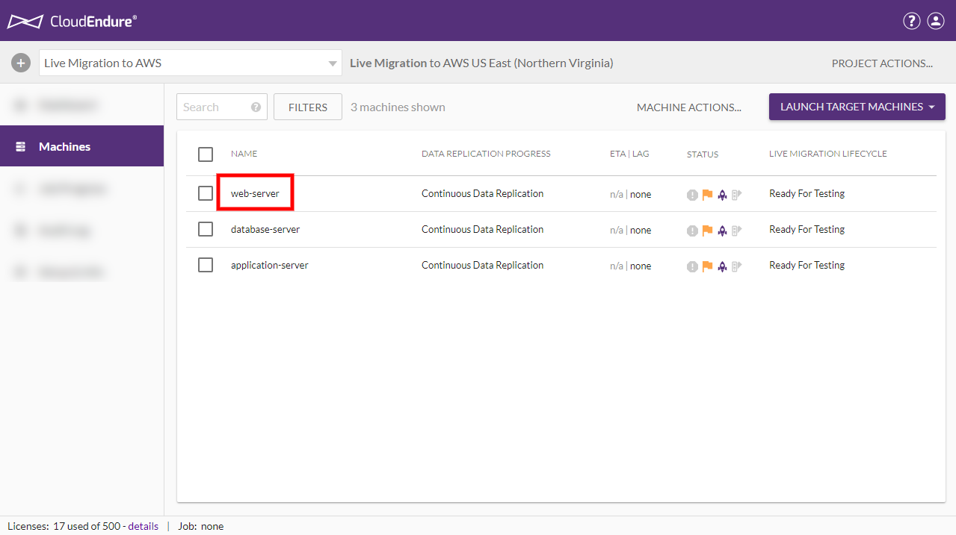

The Machine Details View will automatically open to the **BLUEPRINT** tab. Here, you can set a variety of settings, including:

* **Machine Type** – Select the type of [Target machine](javascript:void(0);) from the dropdown menu. Make sure to select the [machine](javascript:void(0);) type that matches the requirements of the application.
* **Subnet** - You can select an existing Subnet or create a totally new subnet.
* **Security groups** – Security Groups are connected to subnets. You can change the default [Security Group](javascript:void(0);) only if you selected an existing subnet (and NOT the **Create New** option). Therefore, if you want to configure the Security Groups value, it is recommended to set in advance its subnet, so the subnet will already appear on the Subnet drop-down list.
* **Private IP** – Each [machine](javascript:void(0);) that is launched in the cloud will be allocated a Private IP. By default, a new Private IP is created. You can also set a custom Private IP.

**Note**: If you set a new Private IP, verify that it is part of the Subnet range and that it is not already taken/used.

* **Elastic IP** – a fixed Public IP that the cloud allocates. Select whether you would like to not use an Elastic IP (none), create a new one, or use an existing.
* **Public IP (ephemeral)** – Select whether you would like to use a Public IP. You also have the option to use the Public IP according to Subnet configuration. This only applies when the Elastic IP value is **none**.
* **IAM Role** – Select an IAM role of the [machine](javascript:void(0);) if you would like to associate it with a particular IAM in AWS.
* **Placement Group** - Select a Placement Group to associate with the [machine](javascript:void(0);), if applicable.
* **Initial Target Instance State** – Select whether you want the initial [Target](javascript:void(0);) instance to be in a started state or in a stopped state.
* **Tags** – Add a limited number of optional [AWS tags](http://docs.aws.amazon.com/AWSEC2/latest/UserGuide/Using_Tags.html).
* **Volumes** – Select the volume type for your [Target](javascript:void(0);) disk. You can select **Standard, SSD**, or **Provisioned SSD**.
* **Note: - By default CloudEndure will take Provisioned IOPS(io1). Make sure to change volume type before performing Test mode launch or final cutover.**

Set your preferred settings and click **SAVE BLUEPRINT**. You will need to adjust the Blueprint individually for each [Source machine](javascript:void(0);). For our purposes, we will use the default settings.

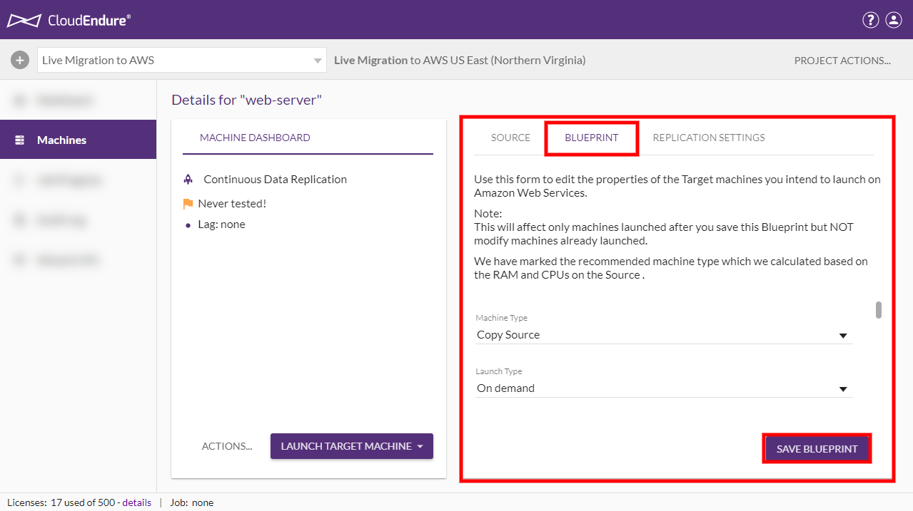

**Launching the Machines in Test Mode**

Once the Blueprint for all machines has been configured, the machines can to be launched in [Test](javascript:void(0);) Mode. You should perform a test at least one week before you plan to migrate your [Source](javascript:void(0);) machines. This time frame is intended for identifying potential problems and solving them, before the actual [Cutover](javascript:void(0);) takes place.

To launch the machines in [Test](javascript:void(0);) Mode, check the box to the left of each [machine](javascript:void(0);) name, open the **LAUNCH TARGET MACHINES** menu, and select **Test Mode**.

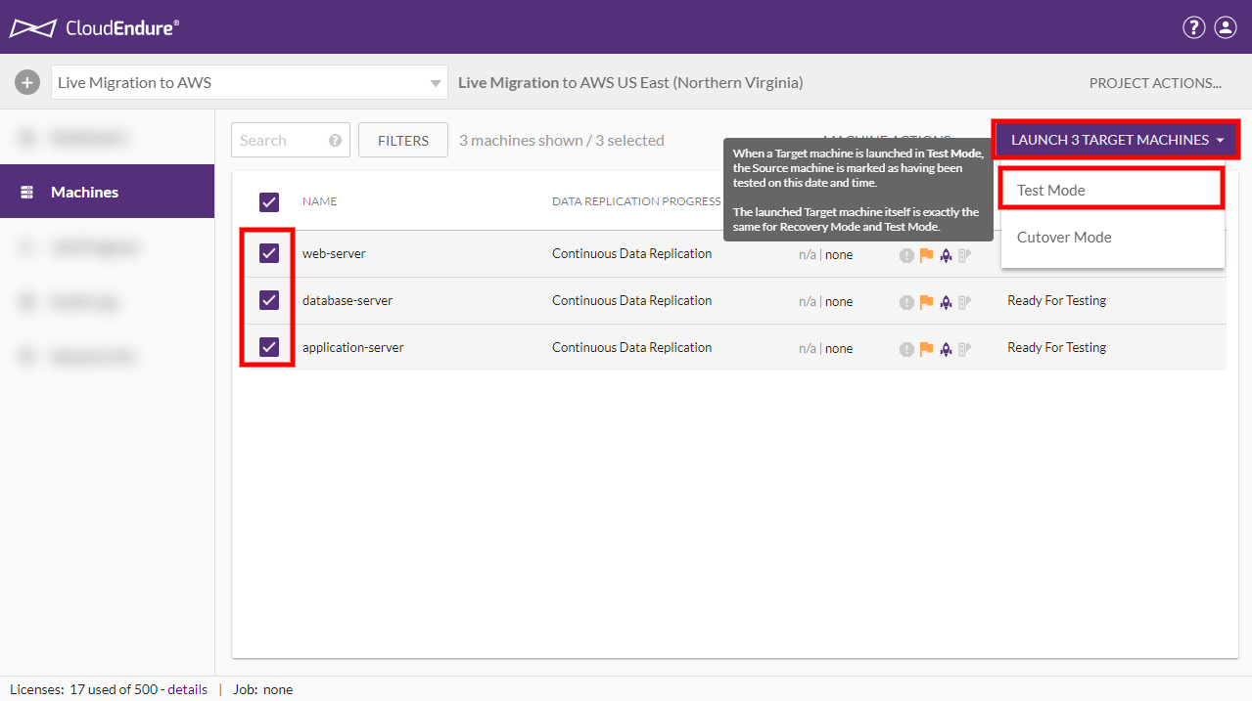

Click **CONTINUE** on the **Launch X Target** machines dialog.

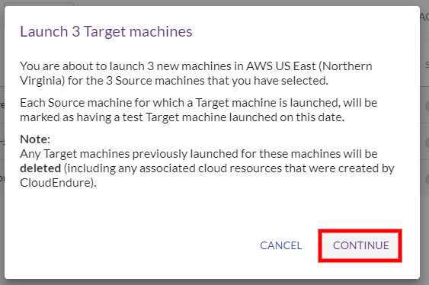

[Target](javascript:void(0);) machines will be launched for the [Source](javascript:void(0);) machines in your [Project](javascript:void(0);), as indicated by the [User Console](javascript:void(0);).

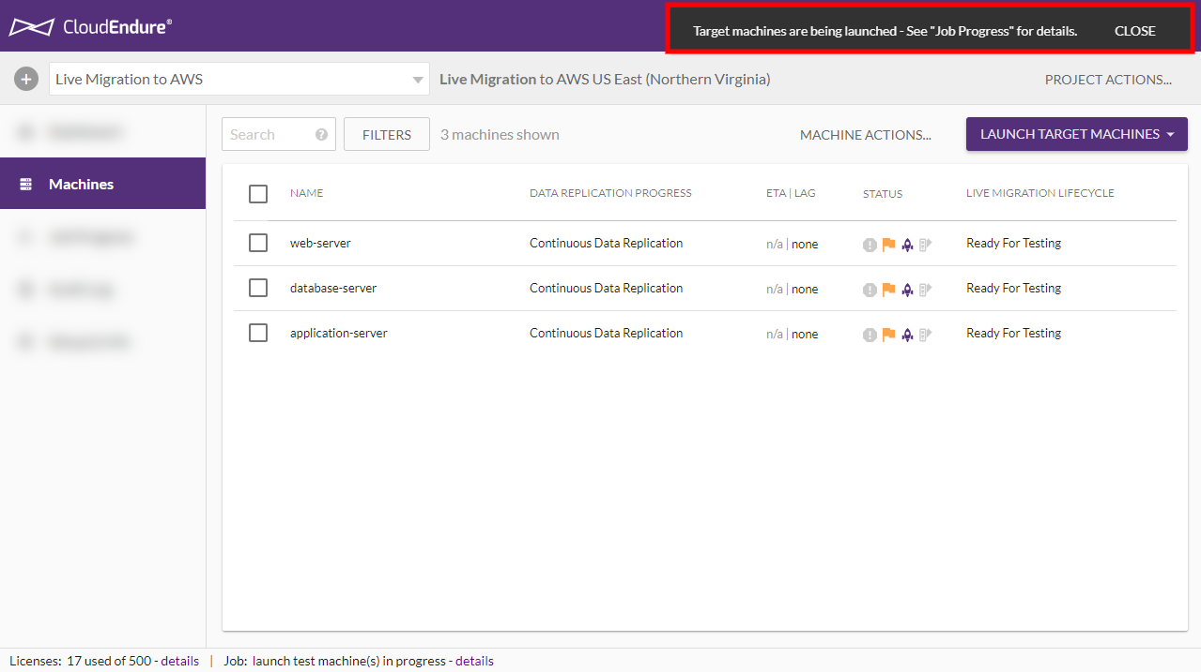

Click on **Job Progress** on the left-hand navigation menu to monitor the launch.

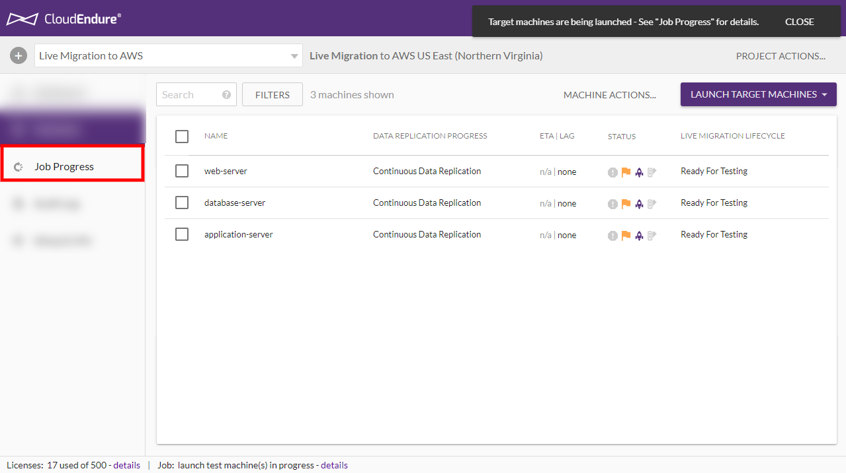

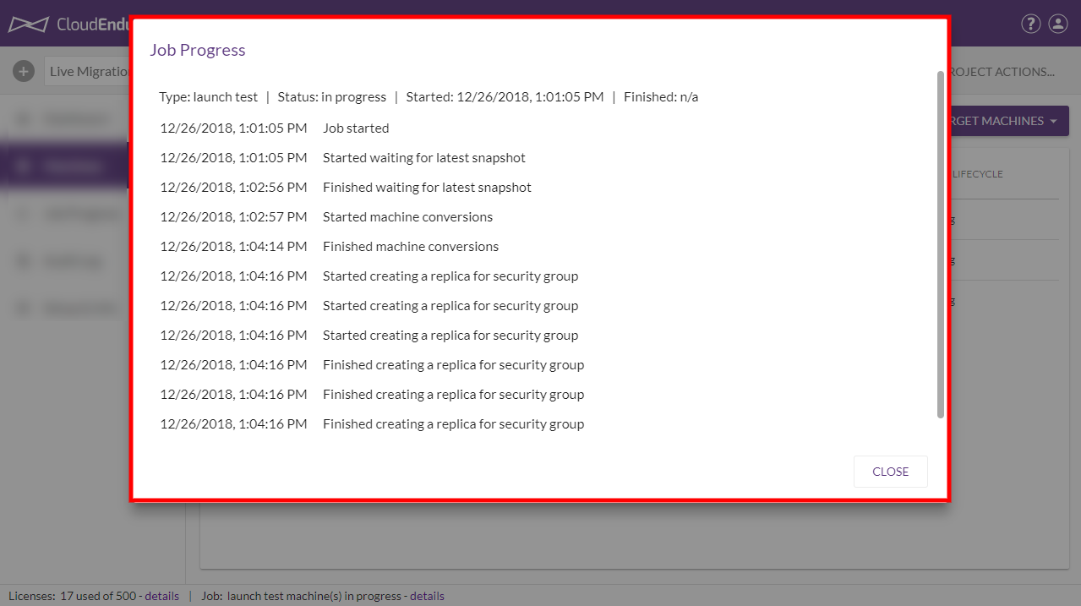

Once [Target](javascript:void(0);) machines have been successfully launched for the [Source](javascript:void(0);) machines in [Test](javascript:void(0);) Mode, several indicators will confirm the launch:

* The server icon in the **STATUS** column will light up, indicating that a [Target machine](javascript:void(0);) has been launched for the [Source machine](javascript:void(0);).
* The orange flag icon under the **STATUS** column will turn off, indicating that the [machine](javascript:void(0);) no longer requires attention.
* The **MIGRATION LIFECYCLE** column will display **Tested** and will show the time of the test.
* A green line will appear to the left of each [machine](javascript:void(0);) name, indicating that the machines are healthy and ready for [Cutover](javascript:void(0);).
* The [User Console](javascript:void(0);) will indicate that the machines have been launched.

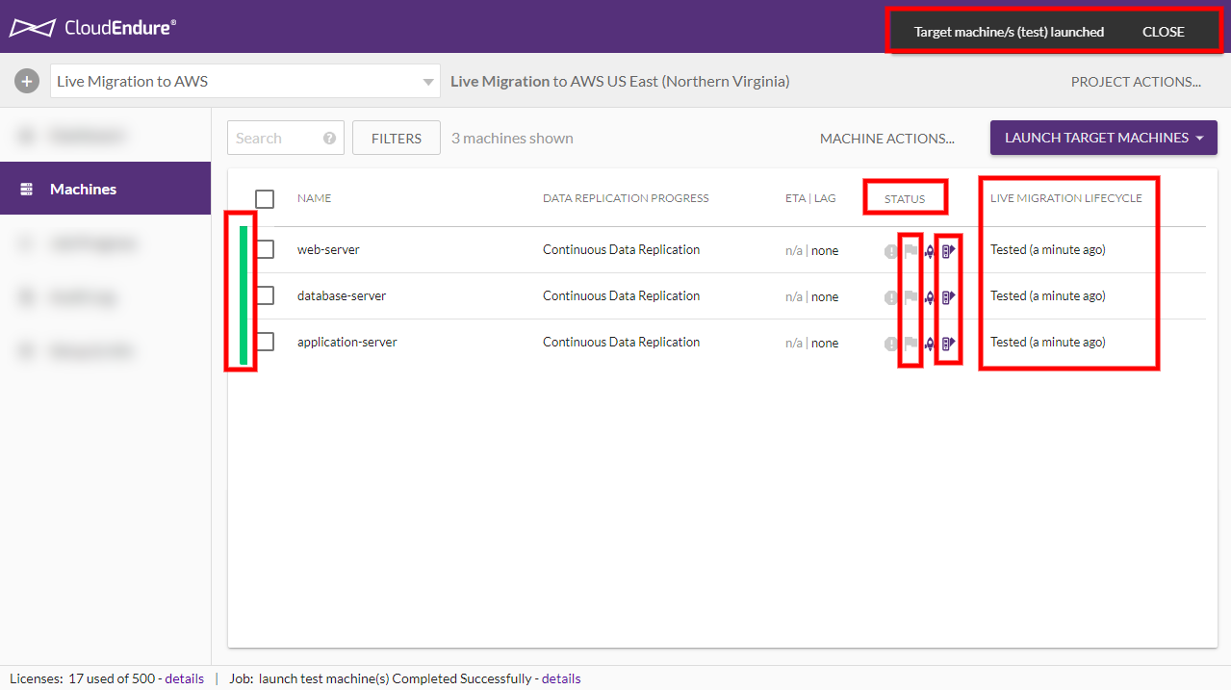

The purpose of the test is to verify that you are able to connect to the machines and that all applications are functioning. You can RDP or SSH into your machines and perform acceptance tests to ensure that they are functioning correctly.

You can find the IP address of the launched [Target machine](javascript:void(0);) by navigating to the **Target** tab within the **Machine Details View** of each [Source machine](javascript:void(0);) that has been launched in **Test Mode**.

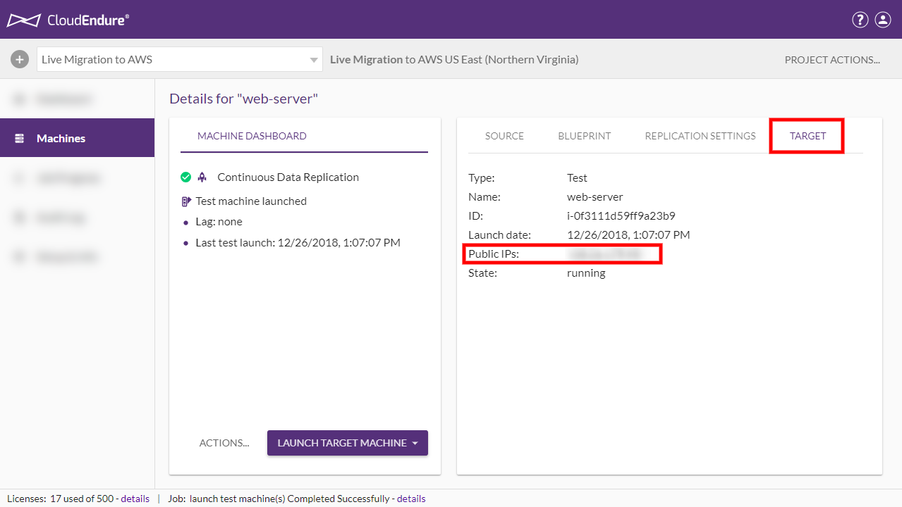

The next step is performing the [Cutover](javascript:void(0);).

**Launching the Machines in Cutover Mode**

After you are done with testing, and are satisfied with the test results, you can launch your [Source](javascript:void(0);) machines in [Cutover](javascript:void(0);) Mode. You should schedule a [Cutover](javascript:void(0);) window for your machines, during which the [Cutover](javascript:void(0);) will occur and the [Source](javascript:void(0);) machines will not be used.

Once you are ready to perform the [Cutover](javascript:void(0);), check the box to the left of every tested [Source machine](javascript:void(0);), open the **LAUNCH TARGET MACHINES** menu, and select **Cutover Mode**.

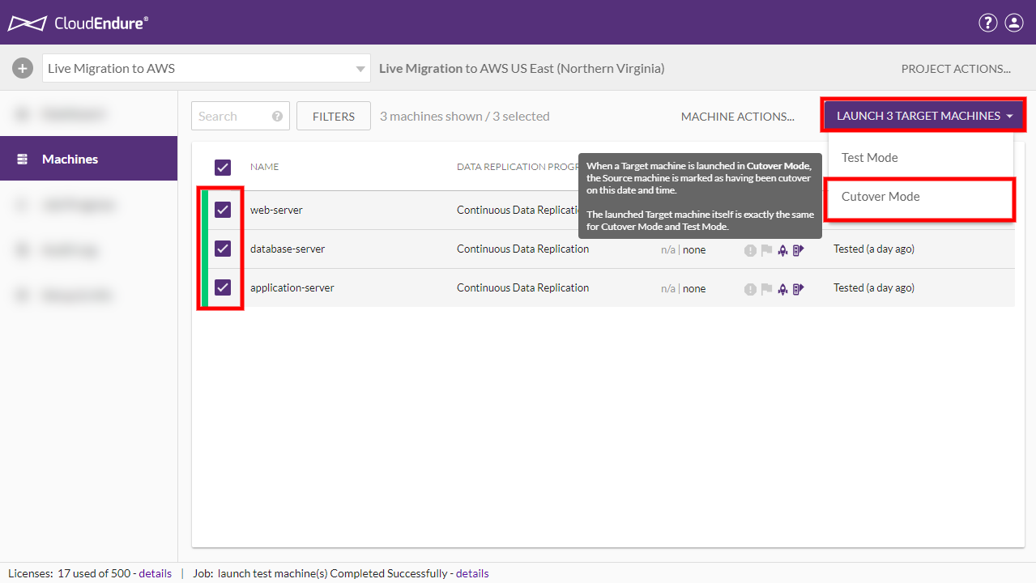

Click **CONTINUE** on the **Launch X Target** machines dialog.

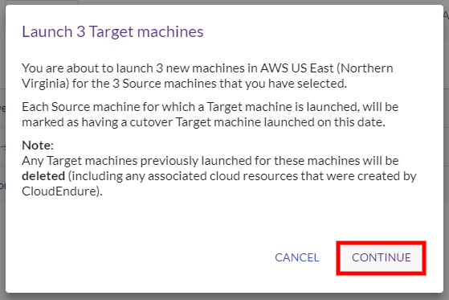

[Target](javascript:void(0);) machines will be launched for the [Source](javascript:void(0);) machines in your [Project](javascript:void(0);), as indicated by the [User Console](javascript:void(0);).

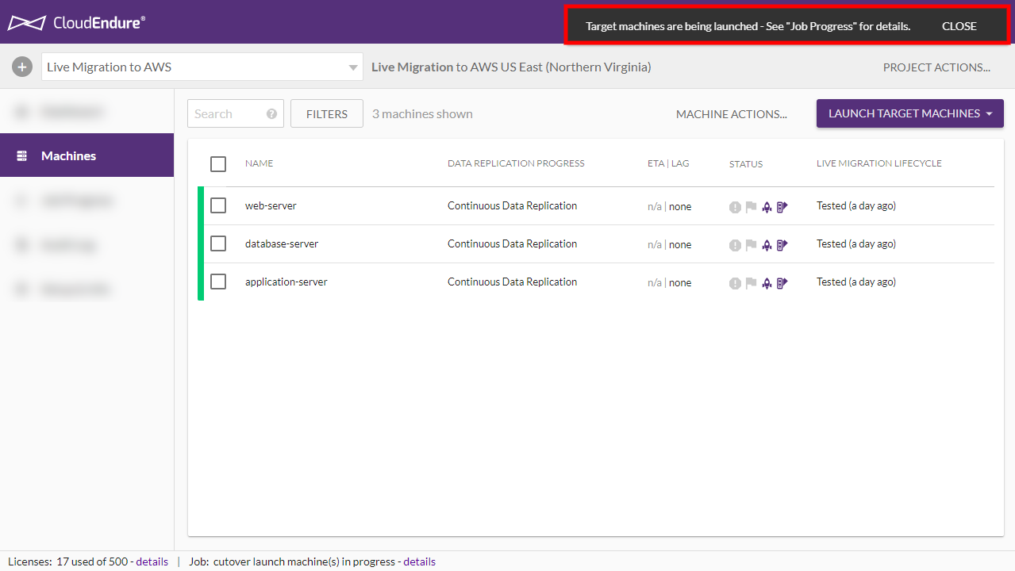

Click on **Job Progress** on the left-hand navigation menu to monitor the launch.

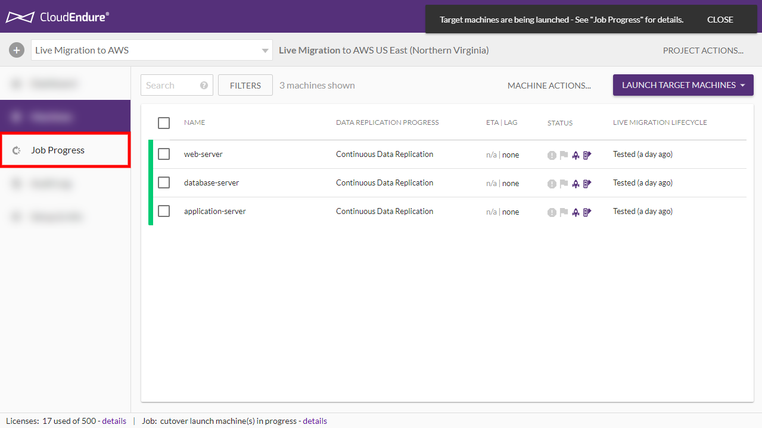

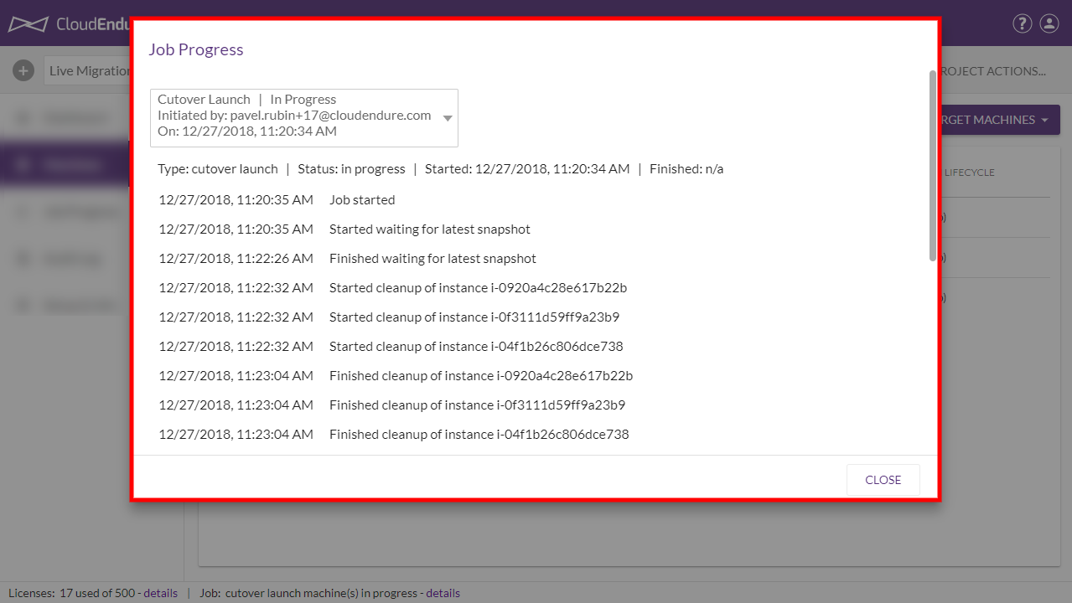

Once [Target](javascript:void(0);) machines have been successfully launched for the [Source](javascript:void(0);) machines in [Cutover](javascript:void(0);) Mode, several indicators will confirm the launch:

* The server icon in the **STATUS** column will light up, indicating that a [Target machine](javascript:void(0);) has been launched for the [Source machine](javascript:void(0);).
* The **MIGRATION LIFECYCLE** column will display **Cutover** and will show the time of the test.
* A green line will appear to the left of each [machine](javascript:void(0);) name, indicating that the machines are healthy.
* The [User Console](javascript:void(0);) will indicate that the machines have been launched.

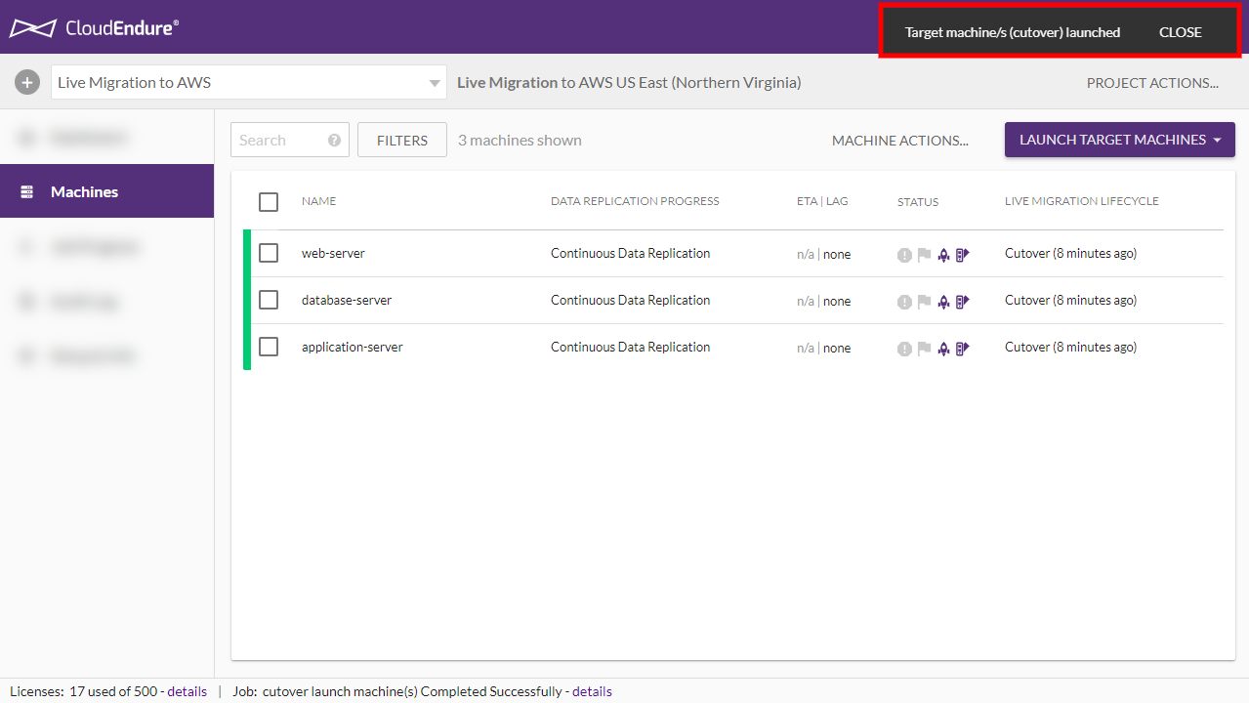

The [Cutover](javascript:void(0);) is now complete. The next step is removing [Source](javascript:void(0);) machines from the [User Console](javascript:void(0);).

**Removing Source Machines from the User Console**

The [Cutover](javascript:void(0);) has now been completed and our [Source](javascript:void(0);) machines have been migrated to AWS US East. As a result, we no longer need to keep the original [Source](javascript:void(0);) machines in the CloudEndure [User Console](javascript:void(0);).

You can remove all [Source](javascript:void(0);) machines that have been [Cutover](javascript:void(0);) from the [User Console](javascript:void(0);) by checking the box to the left of each [machine](javascript:void(0);) name, opening the **MACHINE ACTIONS** menu, and selecting the **Remove X Machines from This Console** option.

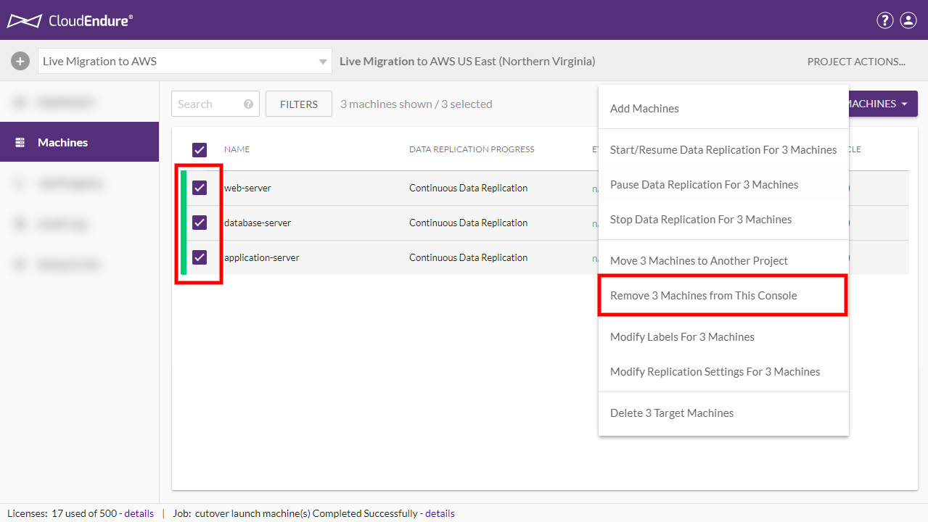

CloudEndure migration

https://aws.amazon.com/cloudendure-migration/

Migration process workflow

<https://docs.cloudendure.com/Content/FAQ/FAQ/Migration_Related.htm>

Create IAM user and assign policy for CloudEndure

https://docs.cloudendure.com/Content/Generating\_and\_Using\_Your\_Credentials/Working\_with\_AWS\_Credentials/Generating\_the\_Required\_AWS\_Credentials/Generating\_the\_Required\_AWS\_Credentials.htm

Network Requirements

<https://docs.cloudendure.com/Content/Preparing_Your_Environments/Network_Requirements/Network_Requirements.htm>

----------------------------------------------------------------End------------------------------------------------------------------